A

**PROJECT REPORT**

On

***“ TRAVELORE – BOOK YOUR TRIP ”***



**Submitted in partial fulfilment of the requirements**

**for the award of the degree of**

**Bachelor of Computer Applications.**

**PROJECT GUIDE** **:**  **SUBMITTED BY:**

Mr. Pramod Joshi Chetan Belwal

(Assistant Professor) 180945330046

**Submitted To:**

Faculty of Computer Science & Applications

Amrapali Institute of Applied Sciences, Haldwani

**Study Centre:**

**Amrapali Institutes of Applied Sciences**

**Shiksha Nagar, Haldwani**

(Affiliated by Kumaun University, Nainital)

**DECLARATION**

I hereby declare that the work which is being present in this project report **“TRAVELORE”**, in partial fulfilment of the requirement for the Award of the degree of **BACHELOR OF COMPUTER APPLICATION**, submitted at **AMRAPALI INSTITUTE OF MANAGEMENT AND COMPUTER APPLICATION** is an authentic work done by me during period from 1stJanuary 2021 to 30th July 2021

**Project Guide: Signature of the Student:**

**Mr Pramod Joshi Chetan Belwal**

Roll No -180945330046

# ACKNOWLEDGEMENT

I would like to extend our thanks and appreciation to all those who have assisted us either directly or indirectly and participated in the success of this project.

I would like to thank my guide **Mr Pramod Joshi** for his constant support in the making of the project. As a part of University Curriculum, a final year project is a paramount importance to an BCA student’s curriculum and being our native effort into this project undertook by us, we faced a lot of impediments on our way to the completion of this project but constant guidance and able support of concerned software engineer members lend us a great help in successful completion of the project.

I am thankful to **all staff members** who helped me whenever required, during my project.

Even though I expressed my gratitude to every person, who helped me in reaching this stage, but there might be a few, who’d have been left out, who helped me without my knowledge, I would like to thank all of them.

Last but not least, to all my friends and fellow students for giving me suggestions and helping us in debugging the code errors and above all the faculty of my Department of Computer Science **Amrapali Institute of Applied Sciences** who have always provided their guidance, support and well wishes.

* **CHETAN BELWAL**

**CERTIFICATE**

This is to certify that this project entitled “**Travelore – Book your Trip**” submitted in partial fulfilment of the degree of Bachelor of Computer Applications to the “**Kumaun University**” through **Amrapali Group of Institutes** done by **Mr. Chetan Belwal**, Roll No**. 180945330046** is an authentic work carried out by him at **Amrapali Group of Institutes** under my guidance. The matter embodied in this project work has not been submitted earlier for the award of any degree or diploma to the best of my knowledge and belief

**Signature of the student Signature of the Guide**

# Table of Contents

CHAPTER 1 – INTRODUCTION 8-11

1.1 - Introduction: 8

1.2 – Processing Environment: 11

CHAPTER 2 – THEORITICAL BACKGROUND 11-18

2.1 - Frontend: 12

2.2 – Backend: 17

2.3 - Database: 18

CHAPTER 3 – SYSTEM ANALYSIS 19-30

3.1 – System Life Cycle: 20

3.2 –Project Development Approach: 24

3.3 – Feasibility Study: 26

3.4 – Requirement Analysis Steps: 28

3.5 –System Requirement And Specifications: 29

CHAPTER 4 – SOFTWARE DESIGN 30-39

4.1 – Data Flow Diagram: 31

4.2 – Use Case Diagram: 35

4.3 – ER Diagram: 37

CHAPTER 5 – DATABASE DESIGN 40-43

CHAPTER 6 – CODING 44-48

6.1 – Modules Description: 44

6.2 – Algorithm: 46

CHAPTER 7 – TESTING 49-53

7.1 – Testing And Debugging: 49

7.2 – Test Cases: 52

7.3 – Security: 53

CHAPTER 8 – IMPLEMENTATION 54-55

CHAPTER 9 – SOFTWARE MAINTENANCE 56-59

CHAPTER 10 – COST AND BENEFIT ANALYSIS 60-61

CHAPTER 11 – SNAPSHOTS 62-73

CHAPTER 12 – ANNEXURE 74-75

12.1 – Conclusions: 74

12.2 – Bibilography: 75

# ABSTRACT

A Travelore is a [website](http://en.wikipedia.org/wiki/Website) on the [internet](http://en.wikipedia.org/wiki/World_wide_web) that is dedicated to [travel.](http://en.wikipedia.org/wiki/Travel) The site may be focused on travel [reviews,](http://en.wikipedia.org/wiki/Review) trip fares, or a combination of both. Many travel websites are online [travelogues](http://en.wikipedia.org/wiki/Travel_literature) or [travel journals,](http://en.wikipedia.org/wiki/Travel_journal) usually created by individual [travelers](http://en.wikipedia.org/wiki/Tourism) and [hosted](http://en.wikipedia.org/wiki/Internet_hosting_service) by companies that generally provide their information to consumers for free. The purpose of website is established fact that Internet users are increasing today. One of the main purposes of the website is to facilitate the offline customer online because customers cannot spend their precious time in markets trying to find out the best deal. India is a country where in a few days holiday, you can enjoy a lot .The problem is that we although having many websites but they offer different kind of services and affordable packages .The customers are enjoying a lot but there is a lack of relationship between travel agency and customers and hence we are establishing that relationship by caring and serving all customers in the same manner that we wish to be served .We need to build a world class team armed with knowledge and backed by technology to advise customers in planning of their holidays and to answer their queries. We will be putting an effort to provide the right choice to the people when they plan a holiday and beware them from the false advertising. We will provide them services which they need in duration of their holiday and we’ll like to hear from our customers because customer feedback will encourage us to improve our services. We also manage some entertainment services during travel if you required. In this website you can choose any package of tour and travel services and enjoy a lot. Packages include best hotel for relaxation, best food and water for your health, best travel services, hot water and shower for your better refreshment.

1 - INTRODUCTION

**Project Name:** Travelore – Book Your Trip

## **1.1 - Introduction**:

The Travelore is a web based application and maintains a centralized repository of all related information. The purpose is to design a system using which one can perform all operations related to traveling and sight-seeing. In the present system a customer has to approach various agencies to find details of places and to book tickets. This often requires a lot of time and effort. A customer may not get the desired information from these offices and often the customer may be misguided. It is tedious for a customer to plan a particular journey and have it executed properly. Travelore contains only relevant packages and services that are a need of customer. Travelore has various packages which are basically services that Tour and Travels provides. Best part is, Travelore uses one account for providing all the package services for customers. Travelore is designed especially for customers who have no time for selection holidays to manage their holiday we developed the travelore. Travelore helps customers to go travel right path for their destination .Travelore saves a lot of time for its users by giving only relevant and filtered services on almost all packages. Travelore is a secured web application build on Nodejs. India one of the most beautiful location of South Asia is also among the popular countries of the world. Therefore this tourist hub welcome more than a 5 million foreign tourist from different location of the world. A trip to this beautiful country can reveal numerous mystic things regarding its culture , art , tradition , history etc. known for its spectacular. Each country is unique when it comes to the scenic beauty , nature of the people living in the country and the hospitality of citizens.

### OBJECTIVE

* To develop a web based application which includes packages at affordable prices
* To provide best travelling services to the customers and travel agents.
* To provide a search platform where a tourist can find their tour places according to their choices.
* To promote responsible and interesting tourism so that people can enjoy their holidays at their favorable places.
* To develop tourism with different cultures so that they enrich the tourism experience and build pride.
* To create and promote forms of tourism that provide healthy interaction opportunities for tourists and locals and increase better understanding of different cultures, customs, lifestyles, traditional knowledge and believes.
* To provide a better way to connect with various events.

## Existing System (Problem Statement):

In the present system a customer has to approach various agencies to find details of places and to book tickets. This often requires a lot of time and effort. A customer may not get the desired information from these offices and often the customer may be misguided. It is tedious for a customer to plan a particular journey and have it executed properly.

## PROPOSED SYSTEM:

The proposed system is a web based application and maintains a centralized repository of all related information. The system allows one to easily access the relevant information and make necessary travel arrangements. Users can decide about places they want to visit and make bookings online for travel and accommodation. User interface is very friendly and for queries user can contact admin directly through contact us module.

## 

## Future Scope:

While at first the system will specialize in agent based booking, in the future it is expected to be able to:

* Make hotel and rental car reservations.
* Issue "ticketless" reservations. For example, "ticketless" flight reservations will work as follows: travel agents making flight reservations will issue travelers confirmation numbers (and not a ticket). At the airline gate the traveler will show photo identification and the gate agent will locate the flight reservation and issue a boarding pass.
* Easy payment methods (By credit card or Net banking or even Cash on Delivery).
* So now this website is going to be a free services website.
* This service gives more discount at a time of a current online booking.
* A traveler can find everything related to travelling services under one roof by this website. The site will help to estimate the benefits and calculate the requirement very easily.

## Modules in Project :

* Login/Logout Module
* Customer Reservation Module
* Token generation
* User Authentication
* Password Hashing
* Tours Module
* Contact us Module
* Newsletter Module

## **1.2 Processing** **Environment**

## Hardware Requirement:

Processor : Pentium III/Core Duo

RAM : 128 MB

Hard disk : 20 GB

Monitor : 14 inch

Mouse : 3 Button scroll

Keyboard : 108 keys

**Software Specification:**

Operating System : Windows 7, 8, 8.1,10

Technology : NodeJs, ExpressJs

Web Technologies : HTML, CSS, Javascript, Bootstrap

Database : MongoDB

2 - THEORITICAL BACKGROUND

## **2.1 - FRONTEND**

### **HTML**:

HTML stands for Hyper Text Markup Language, which is the most widely used language on Web to develop web pages. HTML was created by Berners-Lee in late 1991 but "HTML 2.0" was the first standard HTML specification which was published in 1995. HTML 4.01 was a major version of HTML and it was published in late 1999. Though HTML 4.01 version is widely used but currently we are having HTML-5 version which is an extension to HTML 4.01, and this version was published in 2012.

* + - **Hypertext** refers to the way in which Web pages (HTML documents) are linked together. Thus, the link available on a webpage is called Hypertext.
    - As its name suggests, HTML is a **Markup Language** which means you use HTML

to simply "mark-up" a text document with tags that tell a Web browser how to structure it to display.

* + - HTML describes the structure of Web pages using markup
    - HTML elements are the building blocks of HTML pages
    - HTML elements are represented by tags
    - HTML tags label pieces of content such as "heading", "paragraph", "table", and so on.
    - Browsers do not display the HTML tags, but use them to render the content of the page.

## CSS (Cascading Style Sheets):

Cascading Style Sheets, fondly referred to as CSS, is a simple design language intended to simplify the process of making web pages presentable.

CSS handles the look and feel part of a web page. Using CSS, you can control the color of the text, the style of fonts, the spacing between paragraphs, how columns are sized and laid out, what background images or colors are used, layout designs, variations in display for different devices and screen sizes as well as a variety of other effects.

CSS is easy to learn and understand but it provides powerful control over the presentation of an HTML document. Most commonly, CSS is combined with the markup languages HTML or XHTML.

### Advantages of CSS:

* + - **CSS saves time** − You can write CSS once and then reuse same sheet in multiple HTML pages by linking that particular stylesheet in multiple pages.
    - **Pages load faster** − If you are using CSS, you do not need to write HTML tag attributes every time. Just write one CSS rule of a tag and apply it to all the occurrences of that tag.
    - **Easy maintenance** − To make a global change, simply change the style, and all elements in all the web pages will be updated automatically hence it is easy to maintain a cascading style sheet.
    - **Superior styles to HTML** − CSS has a much wider array of attributes than HTML, so you can give a far better look to your HTML page in comparison to HTML attributes.

Even the code is easy to understand and lightweight

* + - **Multiple Device Compatibility** − Style sheets allow content to be optimized for more than one type of device.
    - **Global web standards** − Now HTML attributes are being deprecated and it is being recommended to use CSS. So its a good idea to start using CSS in all the HTML pages to make them compatible to future browsers.

## Java Script:

JavaScript is a dynamic computer programming language. It is lightweight and most commonly used as a part of web pages, whose implementations allow client-side script to interact with the user and make dynamic pages. It is an interpreted programming language with object-oriented capabilities. JavaScript is often executed directly on a client's browser. JavaScript can also have the same benefits as server-side languages. it always gets executed on client environment to save lots of a bandwidth and make execution process fast.

JavaScript was first known as LiveScript, but Netscape changed its name to JavaScript, possibly because of the excitement being generated by Java. JavaScript made its first appearance in Netscape 2.0 in 1995 with the name LiveScript. The general-purpose core of the language has been embedded in Netscape, Internet Explorer, and other web browsers.

The ECMA-262 Specification defined a standard version of the core JavaScript language.

* + - JavaScript is a lightweight, interpreted programming language.
    - Designed for creating network-centric applications.
    - Complementary to and integrated with Java.
    - Complementary to and integrated with HTML.
    - Open and cross-platform

### Advantages of JavaScript:

The merits of using JavaScript are −

* **Less server interaction** − You can validate user input before sending the page off to the server. This saves server traffic, which means less load on your server.
* **Immediate feedback to the visitors** − They don't have to wait for a page reload to see if they have forgotten to enter something.
* **Increased interactivity** − You can create interfaces that react when the user hovers over them with a mouse or activates them via the keyboard.
* **Richer interfaces** − You can use JavaScript to include such items as drag-and-drop components and sliders to give a Rich Interface to your site visitors.

### **Bootstrap**:

Bootstrap is the most popular front end framework in the recent time. It is sleek, intuitive, and powerful mobile first front-end framework for faster and easier web development. It uses HTML, CSS and Javascript. This tutorial will teach you the basics of Bootstrap Framework using which you can create web projects with ease. The tutorial is divided into sections such as Bootstrap Basic Structure, Bootstrap CSS, Bootstrap Layout Components and Bootstrap Plugins.

### Why Use Bootstrap?

* + - **Mobile first approach** − Bootstrap 3, framework consists of Mobile first styles throughout the entire library instead them of in separate files.
    - **Browser Support** − It is supported by all popular browsers.



* + - **Easy to get started** − With just the knowledge of HTML and CSS anyone can get started with Bootstrap. Also the Bootstrap official site has a good documentation.
    - **Responsive design** − Bootstrap's responsive CSS adjusts to Desktops, Tablets and Mobiles.

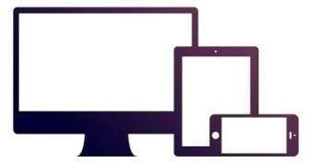

* + - Provides a clean and uniform solution for building an interface for developers.
    - It contains beautiful and functional built-in components which are easy to customize.
    - It also provides web based customization.
    - And best of all it is an open source.

### Advantages of Using Bootstrap:

If you have had some experience with any front-end framework, you might be wondering what makes Bootstrap so special. Here are some advantages why one should opt for Bootstrap framework:

* **Save lots of time** — You can save lots of time and efforts using the Bootstrap predefined design templates and classes and concentrate on other development work.
* **Responsive features** — Using Bootstrap you can easily create responsive websites that appear more appropriately on different devices and screen resolutions without any change in markup.
* **Consistent design** — All Bootstrap components share the same design templates and styles through a central library, so the design and layout of your web pages will be consistent.
* **Easy to use** — Bootstrap is very easy to use. Anybody with the basic working knowledge of HTML, CSS and JavaScript can start development with Bootstrap.
* **Compatible with browsers** — Bootstrap is created with modern web browsers in mind and it is compatible with all modern browsers such as Chrome, Firefox, Safari, Internet Explorer, etc.
* **Open Source** — And the best part is, it is completely free to download and use.

# 2.2 - BACKEND

## Node js-

Node.js is an open source, cross-platform runtime environment for developing server- side and networking applications. Node.js applications are written in JavaScript, and can be run within the Node.js runtime on OS X, Microsoft Windows, and Linux.

Node.js also provides a rich library of various JavaScript modules which simplifies the development of web applications using Node.js to a great extent.

Node.js = Runtime Environment + JavaScript Library

## Features of Node.js

Following are some of the important features that make Node.js the first choice of software architects.

* **Asynchronous and Event Driven** − All APIs of Node.js library are asynchronous, that is, non-blocking. It essentially means a Node.js based server never waits for an API to return data. The server moves to the next API after calling it and a notification mechanism of Events of Node.js helps the server to get a response from the previous API call.
* **Very Fast** − Being built on Google Chrome's V8 JavaScript Engine, Node.js library is very fast in code execution.
* **Single Threaded but Highly Scalable** − Node.js uses a single threaded model with event looping. Event mechanism helps the server to respond in a non-blocking way and makes the server highly scalable as opposed to traditional servers which create limited threads to handle requests. Node.js uses a single threaded program and the same program can provide service to a much larger number of requests than traditional servers like Apache HTTP Server.
* **No Buffering** − Node.js applications never buffer any data. These applications simply output the data in chunks.
* **License −** Node.js is released under the [MIT license](https://raw.githubusercontent.com/joyent/node/v0.12.0/LICENSE).

## Express Js

Express is a small framework that sits on top of Node.js’s web server functionality to simplify its APIs and add helpful new features.It makes it easier to organize your application’s functionality with middle ware and routing; it adds helpful utilities to Node.js’s HTTP objects;it facilitates the rendering of dynamic HTTP objects.Express is a part of MEAN stack, a full stack JavaScript solution used in building fast, robust, and maintainable production web applications.

# 2.3 - DATABASE

## MonGoDb

MongoDB, the most popular NoSQL database, is an open-source document-oriented database. The term ‘NoSQL’ means ‘non-relational’. It means that MongoDB isn’t based on the table-like relational database structure but provides an altogether different mechanism for storage and retrieval of data. This format of storage is called BSON ( similar to JSON format).

SQL databases store data in tabular format. This data is stored in a predefined data model which is not very much flexible for today’s real-world highly growing applications. Modern applications are more networked, social and interactive than ever. Applications are storing more and more data and are accessing it at higher rates.

Relational Database Management System(RDBMS) is not the correct choice when it comes to handling big data by the virtue of their design since they are not horizontally scalable. If the database runs on a single server, then it will reach a scaling limit. NoSQL databases are more scalable and provide superior performance. MongoDB is such a NoSQL database that scales by adding more and more servers and increases productivity with its flexible document model.

3 - System Analysis

## INTRODUCTION

Systems are created to solve problems. One can think of the systems approach as an organized way of dealing with a problem. In this dynamic world, The subject System Analysis and Design, mainly deals with the software development activities. Systems analysis is a **process of collecting factual data**, understand the processes involved, identifying problems and recommending feasible suggestions for improving the system functioning.

## OBJECTIVES

After going through this lesson, you should be able to:

understand a system

understand the different phases of system developments life cycle

know the components of system analysis

know the components of system designing

## Defining A System

A collection of components that work together to realize some objective forms a system. Basically there are three major components in every system, namely input, processing and output.

In a system the different components are connected with each other and they are interdependent. For example, Human body represents a complete natural system. We are also bound by many national systems such as political system, economic system, educational system and so forth. The objective of the system demand that some output is produced as a result of processing the suitable inputs.

**3.1 - SYSTEM LIFE CYCLE**

System life cycle is an organisational process of developing and maintaining systems. It helps in establishing a system project plan, because it gives overall list of processes and sub-processes required developing a system.

System development life cycle means combination of various activities. In other words we can say that various activities put together are referred as system development life cycle. In the System Analysis and Design terminology, the system development life cycle means software development life cycle.

Following are the different phases of software development cycle:

* + 1. System study
    2. Feasibility study
    3. System analysis
    4. System design
    5. Coding
    6. Testing
    7. Implementation
    8. Maintenance

## System Study

System study is the first stage of system development life cycle. This gives a clear picture of what actually the physical system is? In practice, the system study is done in two phases. In the first phase, the preliminary survey of the system is done which helps in identifying the scope of the system. The second phase of the system study is more detailed and in-depth study in which the identification of user’s requirement and the limitations and problems of the present system are studied. After completing the system study, a system proposal is prepared by the System Analyst (who studies the system) and placed before the user. The proposed system contains the findings of the present system and recommendations to overcome the limitations and problems of the present system in the light of the user’s requirements.

## Feasibility Study

On the basis of result of the initial study, feasibility study takes place. The feasibility study is basically the test of the proposed system in the light of its workability, meeting user’s requirements, effective use of resources and .of course, the cost effectiveness. The main goal of feasibility study is not to solve the problem but to achieve the scope. In the process of feasibility study, the cost and benefits are estimated with greater accuracy.

## System Analysis

Assuming that a new system is to be developed, the next phase is system analysis. Analysis involved a detailed study of the current system, leading to specifications of a new system. Analysis is a detailed study of various operations performed by a system and their relationships within and outside the system. During analysis, data are collected on the available files, decision points and transactions handled by the present system. Interviews, on-site observation and questionnaire are the tools used for system analysis. Using the following steps it becomes easy to draw the exact boundary of the new system under consideration:

Keeping in view the problems and new requirements

Workout the pros and cons including new areas of the system

## System Design

Based on the user requirements and the detailed analysis of a new system, the new system must be designed. This is the phase of **system designing**. It is a most crucial phase in the development of a system. Normally, the design proceeds in two stages :

preliminary or general design

Structure or detailed design

Preliminary or general design: In the preliminary or general design, the features of the new system are specified. The costs of implementing these features and the benefits to be derived are estimated. If the project is still considered to be feasible, we move to the detailed design stage.

Structure or Detailed design: In the detailed design stage, computer oriented work begins in earnest. At this stage, the design of the system becomes more structured. Structure design is a blue print of a computer system solution to a given problem having the same components and inter-relationship among the same components as the original problem. Input, output and processing specifications are drawn up in detail. In the design stage, the programming language and the platform in which the new system will run are also decided.

There are several tools and techniques used for designing. These tools and techniques are:

* Flowchart
* Data flow diagram (DFDs)
* Data dictionary
* Structured English
* Decision table
* Decision tree

## Coding

After designing the new system, the whole system is required to be converted into computer understanding language. **Coding** the new system into computer programming language does this. It is an important stage where the defined procedure are transformed into control specifications by the help of a computer language. This is also called the programming phase in which the programmer converts the program specifications into computer instructions, which we refer as **programs**. The programs coordinate the data movements and control the entire process in a system. Algorithm and step by step procedure to perform a task is included.

## Testing

Before actually implementing the new system into operations, a test run of the system is done removing all the bugs, if any. It is an important phase of a successful system. After codifying the whole programs of the system, a test plan should be developed and run on a given set of test data. The output of the test run should match the expected results.

**Unit test**: When the programs have been coded and compiled and brought to working conditions, they must be individually tested with the prepared test data. Any undesirable happening must be noted and debugged (error corrections).

**System Test:** After carrying out the unit test for each of the programs of the system and when errors are removed, then system test is done. At this stage the test is done on actual data. The complete system is executed on the actual data. At each stage of the execution, the results or output of the system is analysed. During the result analysis, it may be found that the outputs are not matching the expected out of the system. In such case, the errors in the particular programs are identified and are fixed and further tested for the expected output.

## Implementation

After having the user acceptance of the new system developed, the implementation phase begins. Implementation is the stage of a project during which theory is turned into practice. During this phase, all the programs of the system are loaded onto the user's computer. After loading the system, training of the users starts. Main topics of such type of training are:

1. How to execute the package
2. How to enter the data
3. How to process the data (processing details)
4. How to take out the reports

## Maintenance

Maintenance is necessary to eliminate errors in the system during its working life and to tune the system to any variations in its working environment. It has been seen that there are always some errors found in the system that must be noted and corrected. It also means the review of the system from time to time. The review of the system is done for knowing the full capabilities of the system and the required changes or the additional requirements.

# 3.2 - PROJECT DEVELOPMENT APPROACH

To solve actual problems in an industry, software developer or a team of developers must incorporate a development strategy that encompasses the process, methods and tools layers and generic phases. This strategy is often referred to as process model or a software developing paradigm. A process model for software developing is chosen based on the nature of project and application, the methods and tools to be used, and the controls and deliverables that are required. All software development can be characterized as a problem solving loop in which four distinct stages are encountered: Status quo, Problem definition, technical development and solution integration. Regardless of the process model that is chosen for a software project all of the stages coexist imultaneously at some level of detail.

## WATERFALL MODEL

The waterfall model is a popular version of the system development life cycle model for software engineering. Often considered the classic approach to the systems development life cycle, the waterfall model describes a development method that is linear and sequential. Waterfall development has distinct goals for each phase of development. Imagine a waterfall on the cliff of a steep mountain. Once the water has flowed over the edge of the cliff and has begun its journey down the side of the mountain, it cannot turn back. It is the same with waterfall development. Once a phase of development is completed, the development proceeds to the next phase and there is no turning back.

The advantage of waterfall development is that it allows for departmentalization and managerial control. A schedule can be set with deadlines for each stage of development and a product can proceed through the development process like a car in a carwash, and theoretically, be delivered on time. Development moves from concept, through design, implementation, testing, installation, troubleshooting, and ends up at operation and maintenance. Each phase of development proceeds in strict order, without any overlapping or iterative steps.

The disadvantage of waterfall development is that it does not allow for much reflection or revision. Once an application is in the testing stage, it is very difficult to go back and change something that was not well-thought out in the concept stage. Alternatives to the waterfall model include joint application development (JAD), rapid application development (RAD), synch and stabilize, build and fix, and the Spiral model.

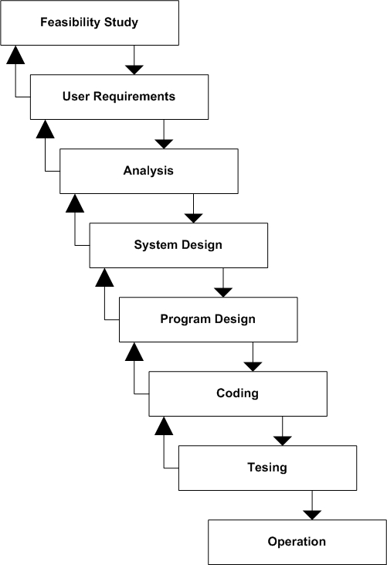

*Figure 1: WATER FALL MODEL*

# 3.3 - FEASIBILITY STUDY

Feasibility study is made to see if the project on completion will serve the purpose of the organization for the amount of work, effort and the time that spend on

it. Feasibility study lets the developer foresee the future of the project and the usefulness. A feasibility study of a system proposal is according to its workability, which is the impact on the organization, ability to meet their user needs and effective use of resources. Thus when a new application is proposed it normally goes through a feasibility study before it is approved for development.

The document provide the feasibility of the project that is being designed and lists various areas that were considered very carefully during the feasibility study of this project such as Technical, Economic and Operational feasibilities. The following are its features:

## TECHNICAL FEASIBILITY

The system must be evaluated from the technical point of view first. The assessment of this feasibility must be based on an outline design of the system requirement in the terms of input, output, programs and procedures. Having identified an outline system, the investigation must go on to suggest the type of equipment, required method developing the system, of running the system once it has been designed.

Technical issues raised during the investigation are:

* Does the existing technology sufficient for the suggested one?
* Can the system expand if developed?

The project should be developed such that the necessary functions and performance are achieved within the constraints. The project is developed within latest technology. Through the technology may become obsolete after some period of time, due to the fact that never version of same software supports older versions, the system may still be used. So there are minimal constraints involved with this project.

## ECONOMIC FEASIBILITY

The developing system must be justified by cost and benefit. Criteria to ensure that effort is concentrated on project, which will give best, return at the earliest. One of the factors, which affect the development of a new system, is the cost it would require.

The following are some of the important financial questions asked during preliminary investigation

* The costs conduct a full system investigation.
* The cost of the hardware and software.
* The benefits in the form of reduced costs or fewer costly errors.

Since the system is developed as part of project work, there is no manual cost to spend for the proposed system. Also all the resources are already available, it give an indication of the system is economically possible for development.

## BEHAVIORAL FEASIBILITY

This includes the following questions:

* Is there sufficient support for the users?
* Will the proposed system cause harm?

## Operational Feasibility

In this we determine what change will be brought in system, new skills required and other human organization and political aspects. Each user can easily use our site. However it is desirable that the user has the basic knowledge of the computers.Without making any changes in the rules and regulations of the existing system proposed system can easily adopted.

**3.4 - REQUIREMENT ANALYSIS STEPS**

Draw Context Diagrams– The context diagram is a simple model that defines the boundaries and interfaces of the proposed system with the external world. It identifies the entities outside the proposed system that interact with the system

Development Of Prototype– One effective way to find out what the customer really wants is to construct a prototype, something that looks and preferably acts like a part of the system they want.

Model The Requirement – This process really consist of various graphical representations of functions, data entities, external entities and the relationship between them. The graphical view may help to find incorrect, inconsistent, missing and superfluous requirement.

Finalize The Requirements– After modeling the requirements we will have better understanding of the system behavior. The inconsistencies and ambiguities have been identified and corrected.

Draw context

Diagram

Draw Prototypes

Model the Requirement

Requirement

Finalize the Requirement

Requirement

**3.5 - SYSTEM REQUIREMENT AND SPECIFICATION**

To be used efficiently, all computer software needs certain hardware components or other software resources to be present on a computer. These prerequisites are known as (computer) system requirements and are often used as a guideline as opposed to an absolute rule. Most software defines two sets of system requirements: minimum and recommended. Software requirements specification establishes the basis for an agreement between customers and contractors or suppliers on how the software product should function

## FUNCTIONAL REQUIREMENTS

A common database maintained & updated time to time. Data is made consistent through data only being entered at one source. The system environment provides for, tan easy to user reporting/enquiry tool for ad-hoc use.

* Customer Registration
* Customer SignIn
* Tour Packages
* Online Tour Reservation
* Newsletter Subscription
* Complain and Query submit
* Package selection
* View and delete package request
* Offer details

.

## NON FUNCTIONAL REQUIREMENTS

They are the quality requirements that stipulate how well software does what it has to do.

* **Performance**

The web application server used should provide good performance and ability to manage performance with techniques such as support for caching.

* **Reliability**

It means the extent to which program performs with required precision. The website

developed should be extremely reliable and secure so that information about any client must. not leaked..

* **Usability**

The website should be user friendly and should require least effort to operate.

* **Portability**

The website is made using HTML, etc.which are platform independent and can be

transported to other servers with minimum effort.

* **Flexibility**

It is effort required to modify operational program. The whole website should be made

using independent modules so that any changes done in 1 module should not affect the other one and new modules can be added easily to increase functionality.

4 - Software Design

## 

Software design is a process to transform user requirements into some suitable form, which helps the programmer in software coding and implementation.

For assessing user requirements, an SRS (Software Requirement Specification) document is created whereas for coding and implementation, there is a need of more specific and detailed requirements in software terms. The output of this process can directly be used into implementation in programming languages.

Software design is the first step in SDLC (Software Design Life Cycle), which moves the concentration from problem domain to solution domain. It tries to specify how to fulfill the requirements mentioned in SRS.

# 4.1 - DATA FLOW DIAGRAM

A DFD also known as ‘bubble chart’ has the purpose of clarifying system requirements and identifying major transformations. It shows the flow of data through a system. It is a graphical tool because it presents a picture. The DFD may be partitioned into levels that represent increasing information flow and functional detail. Four simple notations are used to complete a DFD. These notations are given below:

**DATA FLOW: -** The data flow is used to describe the movement of information from one part of the system to another part. Flows represent data in motion. It is a pipe line through which information flows.

Data flow is represented by an arrow.

Data flow

**PROCESS: -** A circle or bubble represents a process that transforms incoming data to outgoing data. Process shows a part of the system that transform inputs to outputs.

**EXTERNAL ENTITY:-** A square defines a source or destination of system data. External entities represent any entity that supplies or receive information from the system but is not a part of the system.

External Entity

**DATA STORE:-** The data store represents a logical file. A logical file can represent either a data store symbol which can represent either a data structure or a physical file on disk. The data store is used to collect data at rest or a temporary repository of data. It is represented by open rectangle.

Data Store

**Level – 0 Data Flow Diagram**

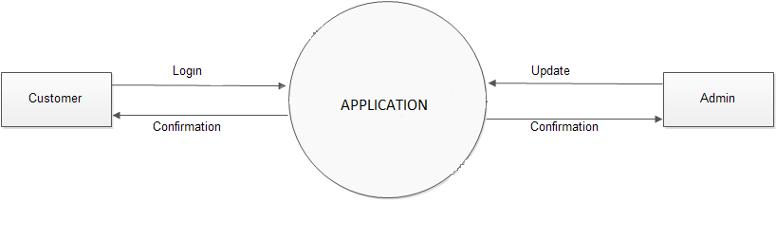

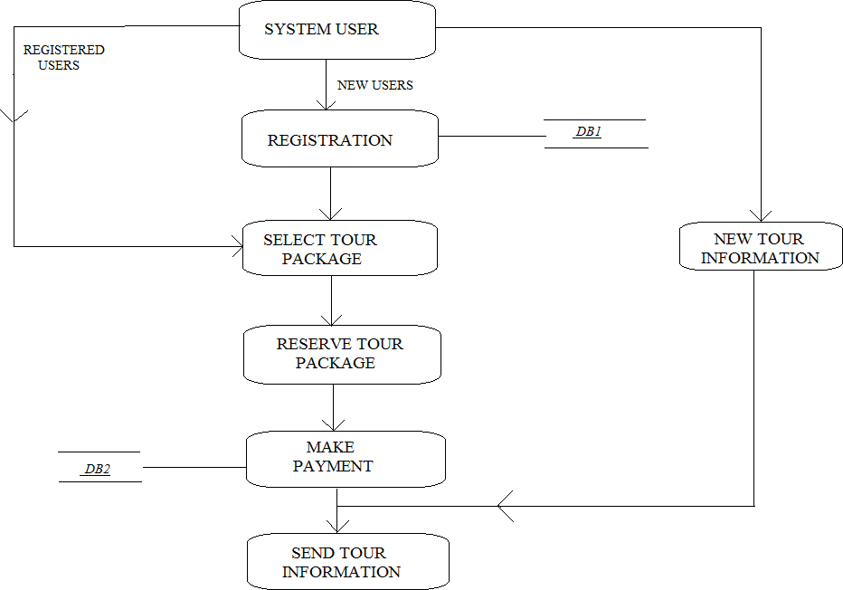**Level – 1 Data Flow Diagram**

# Level - 2 Data Flow Diagram For ADMIN

**Store**

**DB Registers**

**Retreive**

**Login**

**Confirm**

**Tours**

**Add Package**

**Confirm**

**ADMIN**

**View**

**DB Bookings**

**Retreive**

**Confirm**

**Confirm**

**View**

**Retreive**

**DB Subscribers**

**Login**

# Level – 2 Data Flow Diagram For USER

**DB Registers**

**Stores**

**Retreive**

**Login**

**Stores**

**Confirm**

**DB Subscribers**

**Subscribe**

**Confirm**

**User**

**Contact Us**

**Stores**

**Stores**

**DB Contact Us**

**Confirm**

**Tours**

**Confirm**

**Book Now**

**Stores**

**DB Bookings**

# 4.2 USE CASE DIAGRAM

**Actor:** A coherent set of roles that users of use cases play when interacting with the use cases.

**Use Case:** A description of sequence of actions, including variants, that a system performs that yields an observable result of value of an actor.

Use case diagrams model behaviour within a system and helps the developers understand of what the user requires. The stick man represents what’s called an actor.

Use case diagram can be useful for getting an overall view of the system and clarifying who can do and more importantly what they can’t do.

Use case diagram consists of use cases and actors and shows the interaction between the use case and actors.

* The purpose is to show the interactions between the use case and actor.
* To represent the system requirements from user’s perspective.
* An actor could be the end-user of the system or an external system.

A Use case is a description of set of sequence of actions. Graphically it is rendered as an ellipse with solid line including only its name. Use case diagram is a behavioral diagram that shows a set of use cases and actors and their relationship. It is an association between the use cases and actors. An actor represents a real-world object. Primary Actor – Sender, Secondary Actor Receiver.

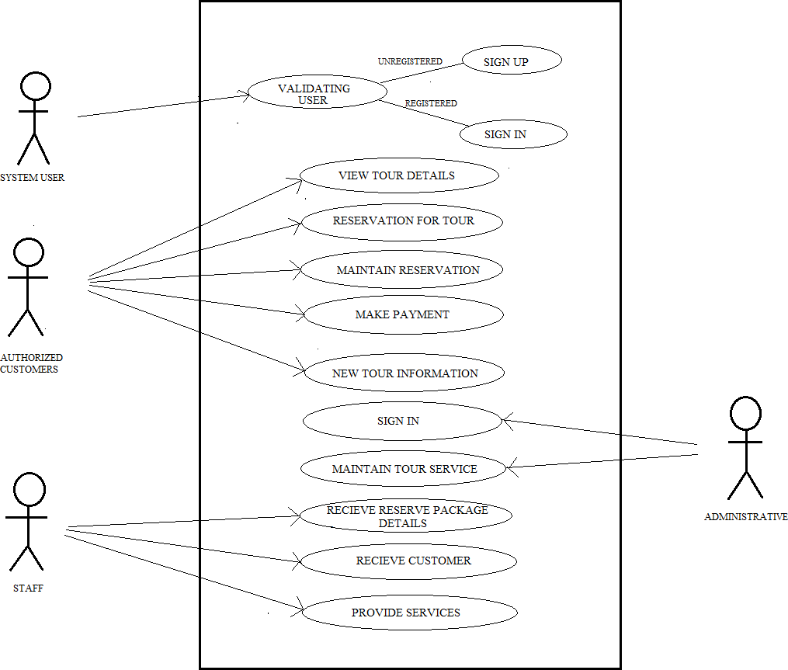

# 4.3 ENTITY RELATIONSHIP DIAGRAM

The entity relationship model was originally proposed by Peter in 1976 as a way to unify the network and relational database views. Simply started the ER model is a conceptual data model that use the real-world entities and relationships. A basic component of the model is the entity relationship diagram which is used to visually represent data objects. Since paper model has been extended and today it is commonly used for database design for the database designer

Entity relationship diagrams are a way to represent the structure and layout of a database. It is used frequently to describe the database schema. ER diagrams are very useful as they provide a good conceptual view of any database, regardless of the underlying hardware and software. An ERD is a model that identifies the concepts or entities that exist in a system and the relationships between those entities. An ERD is often used as a way to visualize a relational database: each entity represents a database table, and the relationship lines represent the keys in one table that point to specific records in related tables.

ERDs may also be more abstract, not necessarily capturing every table needed within a database, but serving to diagram the major concepts and relationships. This ERD is of the latter type, intended to present an abstract, theoretical view of the major entities and relationships needed for management of electronic resources.

The utility of the ER model is:

* It maps well to the relational model. The constructs used in ER model can easily be transformed into relational tables.
* It is simple and easy to understand with a minimum of training. Therefore, the model can be used by the database designer to communicate the design to the end user.
* In addition, the model can be used as a design plan by the database developer to implement a data model in a specific database management software.

There are three main objects on an ER Diagram:

1. Entities
2. Relations
3. Attributes.

**Entities**

An entity is a concept or object in the database. Entities are concepts within the data model. Each entity is represented by a box within the ERD. Entities are abstract concepts, each representing one or more instances of the concept in question. An entity might be considered a container that holds all of the instances of a particular thing in a system. Entities are equivalent to database tables in a relational database, with each row of the table representing an instance of that entity.

**Attributes**

The Supplier Name, Supplier Address, Telephone Number etc. A given attribute belonging to a given entity occurrence can only have one value. Therefore, if a supplier could have more than one address or telephone number then this should be determined before defining the attributes of that entity type. In this example the defined entity may require two or three address and/or telephone number attributes. It is the maximum practical instances of a given attribute that should be catered for in the entity type definition.

**Relationships**

Relations are the connections between two or more entities. Relationship lines indicate that each instance of an entity may have a relationship with instances of the connected entity, and vice versa. Each entity type can always be described in terms of attributes, and these attributes will apply to all occurrences of that given entity type

**book**

**can**

**Register**

**Have to**

**Visitor**

**Login**

**Contact**

**Us**

**Packages**

**Subscribe**

**can**

**Authorized**

**User**

5 - Database Design

In MongoDB, data has a flexible schema. It is totally different from SQL database where you had to determine and declare a table's schema before inserting data. MongoDB collections do not enforce document structure.

The main challenge in data modeling is balancing the need of the application, the performance characteristics of the database engine, and the data retrieval patterns.

Consider the following things while designing the schema in MongoDB

* Always design schema according to user requirements.
* Do join on write operations not on read operations.
* Objects which you want to use together, should be combined into one document. Otherwise they should be separated (make sure that there should not be need of joins).
* Optimize your schema for more frequent use cases.
* Do complex aggregation in the schema.
* You should duplicate the data but in a limit, because disc space is cheaper than compute time

When you are designing your MongoDB schema design, the only thing that matters is that you design a schema that will work well for _your_ application. Two different apps that use the same exact data might have very different schemas if the applications are used differently. When designing a schema, we want to take into consideration the following:

* Store the data
* Provide good query performance
* Require reasonable amount of hardware

With MongoDB, you may embed related data in a single structure or document. These schema are generally known as "denormalized" models, and take advantage of MongoDB's rich documents.

# Collections in Database

A collection is a grouping of MongoDB documents. Documents within a collection can have different fields. A collection is the equivalent of a table in a relational database system. A collection exists within a single database.

The Collections screen lists the existing [collections](https://docs.mongodb.com/compass/current/collections/#std-label-compass-collections) and [views](https://docs.mongodb.com/compass/current/views/#std-label-compass-views) in the selected database. Each list item includes the name and other general information for the collection or view.

The **Collections** screen displays the following information for each collection in the selected database:

* Collection name
* Number of [documents](https://docs.mongodb.com/compass/current/documents/) in the collection
* Average size of documents in the collection
* Total size of all documents in the collection
* Number of [indexes](https://docs.mongodb.com/compass/current/indexes/) on the collection
* Total size of all indexes on the collection
* [Collation](https://docs.mongodb.com/manual/reference/collation/) properties for the collection. Hover over a Collation banner to view the properties for that collection.

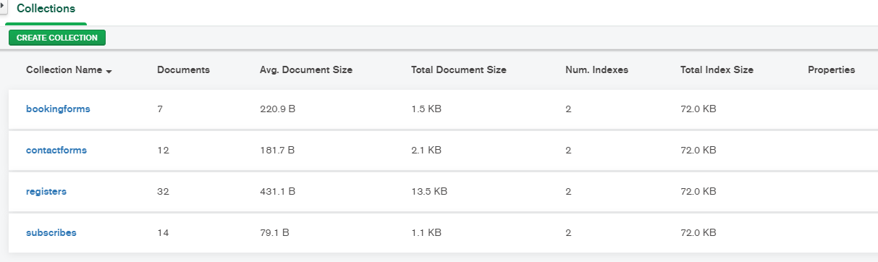

# C:\Users\lenovo\Pictures\Reoster form.pngDatabase - Registers

# Database - ContactUs

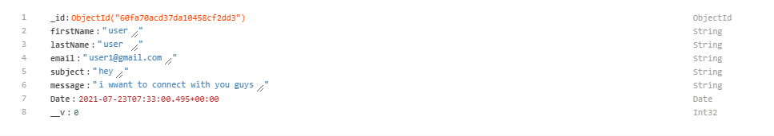

# Database - Subscribers

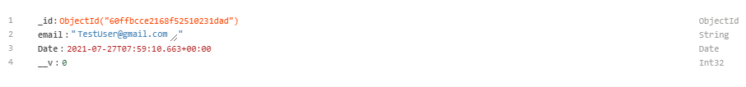

# Database – Bookings

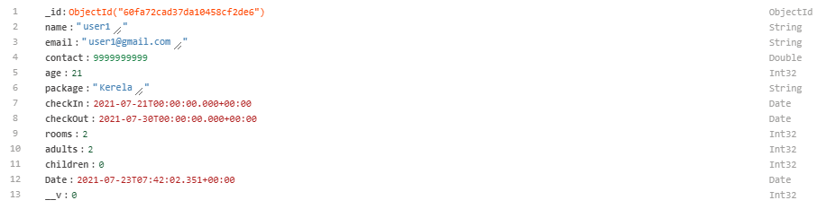

6 - Coding

**6.1 - Modules description**

The different Modules involved in Travelore – Book Your Trip are as follows.

* Login/Logout Module
* Customer Reservation Module
* Token generation
* User Authentication
* Password Hashing
* Tours Packages Module
* Contact us Module
* Newsletter Module

## Login Logout Module:

Loging out means to end access to a computer system or a website. Logging out informs the computer or website that the current user wishes to end the login session. There is automatic logout functionality .Everytime user Logout cookies are cleared and for accessing his/her profile user have to login again  Log out is also known as log off, sign off or sign out.

## Customer Reservation

The customer are given the facility to make online directly.Theyhas to register themselves as registered customers. It is made to authentication of the customers, , and creation of a profile for each traveler. Each customer is identified by the user name. The customer confirms their reservation or makes any query using the user id.

## Token Generation:

There is automatic token generated for the new registers that is unique for each user. For generating tokens we have used Json web token (jwt).

## User Authentication:

An access token is generated by the logon services when a user logs on to the system and the credentials provided by the user are authenticated that proves that the user is genuine who is login present.

## Password Hashing:

Hashing performs a one-way transformation on a password, turning the password into another String, called the hashed password. “One Way” means that is practically impossible to go to the other way - to turn the hashed password back into the original password. This create our database more secure as the user password is saved in hashed form in 10 rounds.

## Tours Packages Module

Travelore offers a variety of tours for Groups and Individual tourists and has been able to mastermind tour packages with great deal of efficiency. Our Inbound Tour division specializes in a wide spectrum of tours packages. This enables us to assure immediate reservations to our customers and provide them with relevant online information. This not only saves your time but also helps you to compare and find the best deals on your travel.

## Contacts Module :

Contact us form is a module which displays a form to site visitors to contact site admin or send any inquiry. The inquiry can be any type like feedback, requesting more new packages, more info or lead. The form simply has few common fields like name, Email, Subject, Message(Query).

## Newsletter Module :

Simply Latest Trending News, Blogs, Offers, New Arrivals, Deals are send newsletters to list of subscribers. All the user have their wish whether they want to subscribe or not.

# 6.2 - ALGORITHM

## Customer Registration

**Step1**. Start

**Step2**. Enter To The Site’s Welcome Page

**Step3**. Click On The “New Register” Button

**Step4**. Fill Up The Registration Form In The Site

**Step5**. Set User Name, Email And Password

**Step** 6.Click on “Register” Button

**Step7**. Stop.

## Customer Login

**Step1**. Start

**Step2**. Enter To The Site’s Welcome Page

**Step3**. Click On The “Log In” Button

**Step4**. Enter Email and Password

**Step** 5.Click on “LogIn” Button

**Step6**. Stop.

## Tour Packages Booking

**Step1**. Start

**Step2**. Enter To The Site’s Home Page

**Step3**. Click On The “Tour” Link

**Step4**. Select Category Package.

**Step5**.Click on “Book now” Button

**Step** **6**.Fill up the Travellers Details Form

**Step7**. Stop.

## Enter Contact us Form:

**Step1**. Start

**Step2**. Enter To The Site’s Home Page

**Step3**. Click On The “Contact Us” Link

**Step4**. Enter Name, Email, Subject and Message

**Step** 5.Click on “Submit" Button.

**Step6**. Stop.

## Subscribe Newsletter:

**Step1**. Start

**Step2**. Enter To The Site’s Footer Section

**Step3**. Enter Email.

**Step4**. Click on “Subscribe” Button

**Step5**. Stop.

7 – TESTING

# 7.1 - TESTING & DEBUGGING

Testing is the one of the most essential process that involve checking of the entire software files that helps in the proper functioning of the software. Testing provides a way of finding out the errors & faults that might have occurred during the development of the software. During the process of the testing of the software, all the necessary errors & faults that have occurred or arisen are traced & proper solutions regarding the errors.

Testing acts as an important phase of the software development life cycle.

Errors Faults defines the number of errors that have occurred during the development of the software that in effect have changed or diverted the entire process of the functioning of the software. The second important factor that comes out as result of testing is Reliability. By testing the entire software, we can easily find out the reliability of the software. So, testing provides a platform for the software developers to develop software that are error free and in effect, efficient and reliable.

Testing can be categorized into the following types depending on their use and purpose in the development of the software. They are:-

**1. Functional Testing:**Functional testing of the software comprises of testing of the function and modules that were created in the software and checking the accuracy of the functioning of the modules and functions that have been used in the proper and effective working of the software.

**2. Structural Testing: -**Structural Testing involves the process of testing the entire

structure of the software that is developed (i.e. Logical as well as physical). All the logical steps related to the logical structure and the physical structure are tested for their accurate functioning and satisfaction for the developer.

**Test criteria:**

* + - **Stability (ST)** – Focusing on the application being stable on the device.
    - **Application Launch (AL)** – Once an application is loaded it must start (launch) and stop correctly in relation to the device and other applications on the device.
    - **Localization (LO)** - Applications that are to be deployed to localities other than their point of origin must account for changes in language, alphabets, date and money formats, etc.
    - **Functionality (FN)** - Documented features are implemented in the application and work as expected. Sources for the information are user manuals, formatted application specification documents and online documentation.
    - **Connectivity (CO)** - If an application has communication capabilities then it must demonstrate its ability to communicate over a network correctly. It must be capable of dealing with both network problems and server-side problems.
    - **Personal Information Management (PI)** - The application accessing user information needs to be able to do it in an appropriate manner and not to destroy the information.
    - **Security (SE)** - Listing different security related issues like username and password of the user tested from the applications.
    - **Retesting (RE)** - Tests specific to retesting only.

**Testing Methodologies**

Black Box Testing It is the testing process in which tester can perform testing on an application without having any internal structural knowledge of application. Usually Test Engineers are involved in the black box testing.

White Box Testing It is the testing process in which tester can perform testing on an application with having internal structural knowledge. Usually the Developers are involved in white box testing**.**

## **Grey Box Testing** It is the process in which the combination of black box and white box tonics are used.

Debugging:

Testing is the process of checking the errors, faults and failures that have occurred during the development or during the running of the system and which in turns have caused problems in the proper functioning of the system. Testing just provides a medium for searching out errors. On the other hand, de-bugging allows developers of the software to remove or make corrections on the errors that were found during testing of the software as de-bugging means, “removing of bugs”.

To debug a program, user has to start with a problem, isolate the source code of the problem, and then fix it. A user of a program must know how to fix the problem as knowledge about problem analysis is expected. When the bug is fixed, then the software is ready to use. Debugging tools (called debuggers) are used to identify coding errors at various development stages. They are used to reproduce the conditions in which error has occurred, then examine the program state at that time and locate the cause. Programmers can trace the program execution step-by-step by evaluating the value of variables and stop the execution wherever required to get the value of variables or reset the program variables. Some programming language packages provide a debugger for checking the code for errors while it is being written at run time.

Here’s the debugging process:  
  
1.Reproduce the problem.  
  
2. Describe the bug. Try to get as much input from the user to get the exact reason.  
  
3. Capture the program snapshot when the bug appears. Try to get all the variable values and states of the program at that time.  
  
4. Analyse the snapshot based on the state and action. Based on that try to find the cause of the bug.  
  
5. Fix the existing bug, but also check that any new bug does not occur.

# 7.2 - Test Cases

|  |  |  |  |  |
| --- | --- | --- | --- | --- |
| **Serial No** | **Description** | **Expected Result** | **Actual Result** | **Result** |
| **1** | Correct username & password of Admin. | System, should accept It. | Get login of the administrator. | **P**assed |
| **2** | Incorrect username & password of Admin. | System should reject It. | Invalid username or password. | **P**assed |
| **3** | Faculty/User fills correct details for registration. | System should allow registering. | Faculty/User gets registered. | **P**assed |
| **5** | Faculty/User fills wrong details for registration. | System should not allow registering. | Faculty/User do not get registered. | **P**assed |
| **6** | Faculty/User uses existing Email Id | System should not allow registering. | Email already existed. | **P**assed |
| **7** | Faculty/User entered password and Re-enter password not match | System should not allow registering. | Password doeds not match. | **P**assed |
| **8** | Faculty/User entered information left somewhere blank. | System should not allow registering | Faculty/User do not get registered | **Passed** |

# 7.3 – SECURITY

Security of the system means to define the safety of the software or the system. Software’s whether they may be large or small security play a vital role in improving the reliability and efficiency of the software. By securing the software at all the levels of the software makes the application as well as the software more reliable & efficient in working or functioning.

Security or safety of the system or the software can be done in many ways. These can be categorized as:-

**Physical Security:-** The term physical security of safety of the software, one means define the physical structure of the software safe and secure. This can be achieved by providing appropriate checks at each and every level of data entry and also by not giving any kind of structural changes in the software they are working on.

**Application Security:**- In the software the text box will accept only those values for which it is placed in the project. Such as it the name of costumer is to be entered in the text then it will accept the only the string value and it will not accept the numeric values and if the user will give any wrong value then it will display the error message

**Administrator Security:-**The administrator is the main of any system and if the user enter the password of the administrator then he/she will enter in administrator mode or only then he/she can change the administration password or add or remove login. Otherwise if any user login he/she can’t be able to access this administrator mode.



**Database Security:**-The database security of the databases that are used in the software in one of the most necessary step that should be kept in the mind while making the software secure as all the data that is purpose. If, by mistake any thing happens to the database, then the entire software is useless or is of no use. So, one should not provide access to databases to the user of the software.

8 - IMPLEMENTATION

System implementation is the stage when the user has thoroughly tested the system and approves all the features provided by the system. The various tests are performed and the system is approved only after all the requirements are met and the user is satisfied.

The new system may be totally new; replacing an existing manual or automated system, or it may a major modification to an existing system. In the either case, proper implementation is essential to provide a reliable system to meet organization requirements successful implementation may not guarantee improvement in the organization using the new system Implementation is the process of having systems personal check out and put new equipment to use, train users, install the new application and construct any files of data needed to use it.

This phase is less creative than system design. Depending on the size of the organization that will be involve in using the application and the risk involved in its use, system developer may choose to test the operation in only one area of the firm with only one or two persons. Sometimes, they will run both old and new system in parallel way to compare the results. In steel other situations, system developers stop using the old systems one day and start using the new one the next.

A number of popular software packages are designed to produce easily readable site traffic reports, complete with data graphics and charts to aid in data analysis. As a service to customers, site hosting companies often offer reports from popular site analysis programs like Web Trends, often free of charge. Before contracting with an Internet Service Provider (ISP) for site hosting services, always ask about site analysis services. If you’re ISP or corporate Web site does not offer a good site traffic analysis package, ask whether the Webmaster can give you access to a monthly server log of your account. Basic versions of traffic analysis programs like Web Trends cost about three hundred dollars, and you can run them on a personal computer if you can gain access to the raw Web server log from your ISP or corporate webmaster.

## 

## **Top-down implementation:**

Top down implementation begins with the user invoked module and works toward the modules that do not call any other modules. The implementation may proceed depth-first or breadth- first.

## Bottom- Up implementation:

Implementation begins with modules that do not call any other modules and work toward the main program. Test harness are used to test individual modules. The main module constitutes the final test harness.

## Stubs:

Stub programming is the implementation analogue of top-down and stepwise refinement. It supports incremental program development by allowing for error and improvement. A stub program is a stripped-down, skeleton version of a final program. It doesn't implement details of the algorithm or fulfill all the job requirements. However, it does contain rough versions of all subprograms and their parameter lists. Furthermore, it can be compiled and run. Extensive use of procedures and parameter are the difference between stub programs and prototypes. Quick and dirty prototypes should be improved and rewritten. A stub program helps demonstrates that a program's structure is plausible. Its procedures and functions are unsophisticated versions of their final forms, but they allow limited use of the entire program. In particular, it may work for a limited data set. Often the high-level procedures are ready to call lower-level code, even if the more detailed subprograms haven't even been written.

11 – Software Maintenance

The maintenance starts after the final software product is delivered to the client. The maintenance phase identifies and implements the change associated with the correction of errors that may arise after the customer has started using the developed software. This also maintains the change associated with changes in the software environment and customer requirements. Once the system is a live one, Maintenance phase is important. Service after sale is a must and users/ clients must be helped after the system is implemented. If he/she faces any problem in using the system, one

or two trained persons from developer’s side can be deputed at the client’s site, so as to avoid any problem and if any problem occurs immediate solution may be provided.

Even though the definition of equivalence partitioning states that testing one value from a class is equivalent to testing any other value from that class, we need to look at the boundaries of equivalent classes more closely. This is so since boundaries are more error prone.

To design two valid cases at both the ends test cases using boundary value analysis, for a range of values,

* + - Two valid cases at both the ends
    - Two invalid cases just beyond the range limits

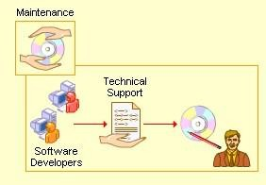

## Cause Effect Analysis:

* + - The main drawback of the previous two techniques is that they do not explore the combination of input conditions.
    - Cause effect analysis is an approach for studying the specifications carefully and identifying the combinations of input conditions (causes) and their effect in the form of a table and designing test cases
    - It is suitable for applications in which combinations of input conditions are few and readily visible.

## Cause Effect Graphing:

This is a rigorous approach, recommended for complex systems only. In such systems the number of inputs and number of equivalent classes for each input could be many and hence the number of input combinations usually is astronomical. Hence we need a systematic approach to select a subset of these input conditions.

Software maintenance is widely accepted part of SDLC now a days. It stands for all the modifications and updations done after the delivery of software product. There are number of reasons, why modifications are required, some of them are briefly mentioned below:

* + - **Market Conditions** - Policies, which changes over the time, such as taxation and newly introduced constraints like, how to maintain bookkeeping, may trigger need for modification.
    - **Client Requirements** - Over the time, customer may ask for new features or functions in the software.
    - **Host Modifications** - If any of the hardware and/or platform (such as operating system) of the target host changes, software changes are needed to keep adaptability.
    - **Organization Changes** - If there is any business level change at client end, such as reduction of organization strength, acquiring another company, organization venturing into new business, need to modify in the original software may arise.

## Types of maintenance:

In a software lifetime, type of maintenance may vary based on its nature. It may be just a routine maintenance tasks as some bug discovered by some user or it may be a large event in itself based on maintenance size or nature. Following are some types of maintenance based on their characteristics:

* + - **Corrective Maintenance** - This includes modifications and updations done in order to correct or fix problems, which are either discovered by user or concluded by user error reports.
    - **Adaptive Maintenance** - This includes modifications and updations applied to keep the software product up-to date and tuned to the ever changing world of technology and business environment.
    - **Perfective Maintenance** - This includes modifications and updates done in order to keep the software usable over long period of time. It includes new features, new user requirements for refining the software and improve its reliability and performance.
    - **Preventive Maintenance** - This includes modifications and updations to prevent future problems of the software. It aims to attend problems, which are not significant at this moment but may cause serious issues in future.

## Cost of Maintenance

Reports suggest that the cost of maintenance is high. A study on estimating software maintenance found that the cost of maintenance is as high as 67% of the cost of entire software process cycle.

On an average, the cost of software maintenance is more than 50% of all SDLC phases. T

here are various factors, which trigger maintenance cost go high

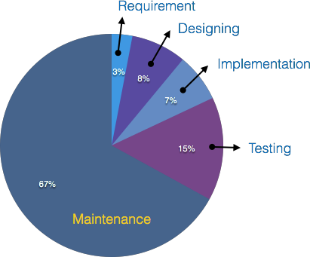

Real-world factors affecting Maintenance Cost

* + - The standard age of any software is considered up to 10 to 15 years.
    - Older softwares, which were meant to work on slow machines with less memory and storage capacity cannot keep themselves challenging against newly coming enhanced softwares on modern hardware.
    - As technology advances, it becomes costly to maintain old software.
    - Most maintenance engineers are newbie and use trial and error method to rectify problem.
    - Often, changes made can easily hurt the original structure of the software, making it hard for any subsequent changes.
    - Structure of Software Program
    - Programming Language
    - Dependence on external environment
    - Staff reliability and availability

10 - COST & BENEFIT ANALYSIS

When the estimates for a system developed, I need to consider several cost elements. Among them are hardware, personal, facility, operating and supply costs.

1. **Hardware Costs :-** Hardware cost relates to the actual purchase or less of the computer and peripherals (for ex. Printer, disk drive, tape etc.). Determining the actual cost of the hardware is generally ore difficult when various users that for a dedicated stand alone system share the system. In some cases the best way to control for this cost is to treat it as an operating cost.
2. **Personal Costs :-**This type of cost include EDP staff salaries and benefits (health insurance, vaccination time etc.) as well as pay for those involved in developing the system. Costs incurred during the development of a system are one time cost.
3. **Facility Cost :-** Facility cost expenses include in the prevention of the physical site where the application or the computer will be in operation. This include wiring, flooring, acoustics, lightning and air cooling. These costs are treated as one time costs are incorporated into the overall cost estimate of the candidate system.
4. **Operating Cost :-** This cost include all cost associated with the day-to-day operations of the System; the amount depends on the number of shifts, the nature of the applications and the caliber of the operating staff. There are various ways of covering operating cost. The amount Charged is based on computer time, staff time and volume of the output produced.
5. **Supply Costs :-** Supply cost are variable cost that increase with increased use of paper, ribbons, disks, and the like. They should be estimated and included in the over all cost of the system. A system is also expected or provides benefits. The first task is to identify each benefit and then assign a monetary value to it for cost/benefit analysis

**Procedure for Cost & Benefit Determination :-** Cost are incurred during throughout its life cycle. Benefits are realized in the form of reduced operating cost, improved operating image, staff efficiency or revenues. To what extent benefits outweigh costs is the function of cost/benefit analysis/ Cost benefit analysis is a procedure that gives a procedure of the various costs, benefit and rules associated with a system. The determination of costs and benefits entails the following step :-

* + Identify the costs and benefit pertaining to given project.
  + Categorized the various costs and benefits for analysis.
  + Select a method of evolution.
  + Interpret the result of analysis.
  + Take action.

**Classification of Costs and Benefit Analysis :-**The next step in cost and benefit determination is to categorized costs and benefits. Following are the Categories :-

* 1. Tangible or Intangible Costs and Benefits.
  2. Direct or Indirect Costs and Benefits.
  3. Fixed or Variable Costs and Benefits.

11 - SNAPSHOTS

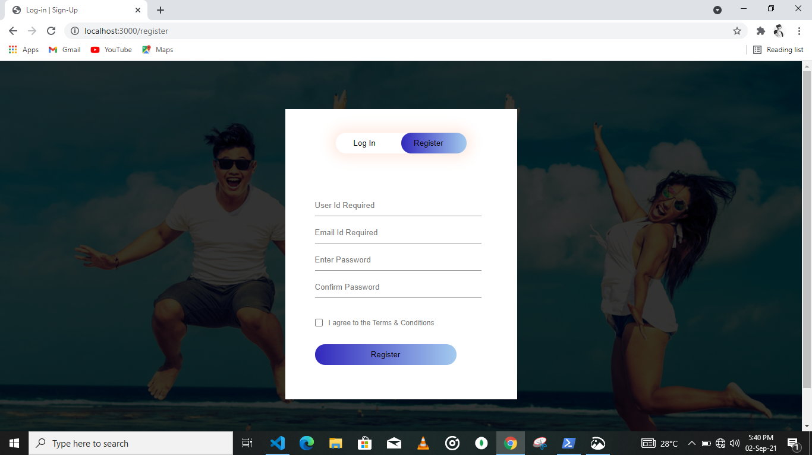

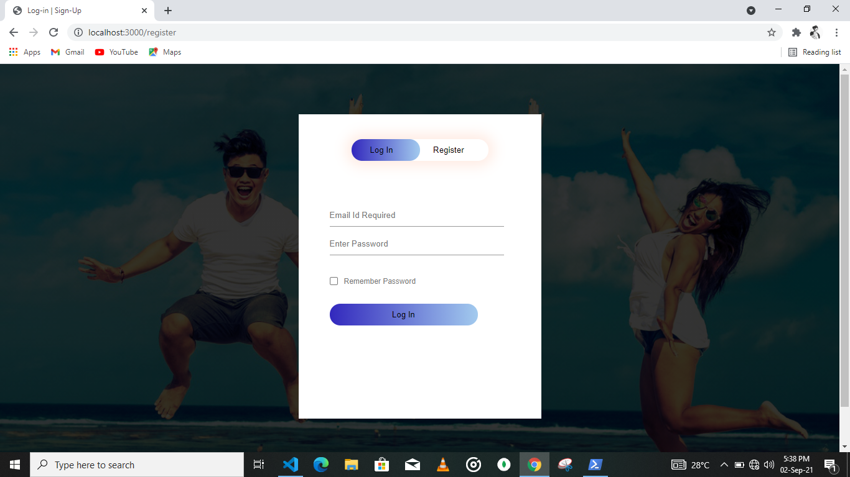

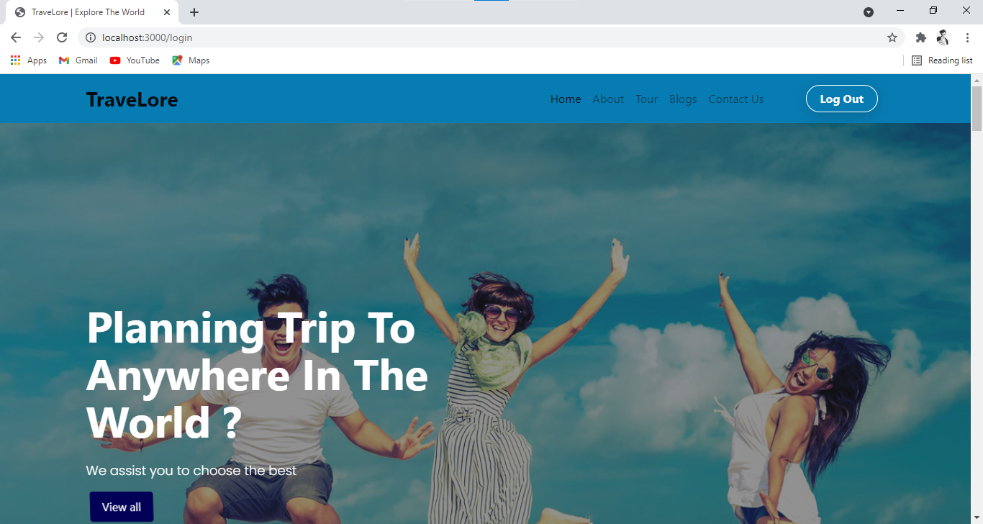

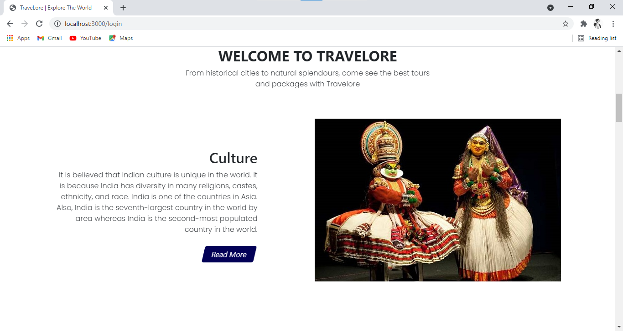

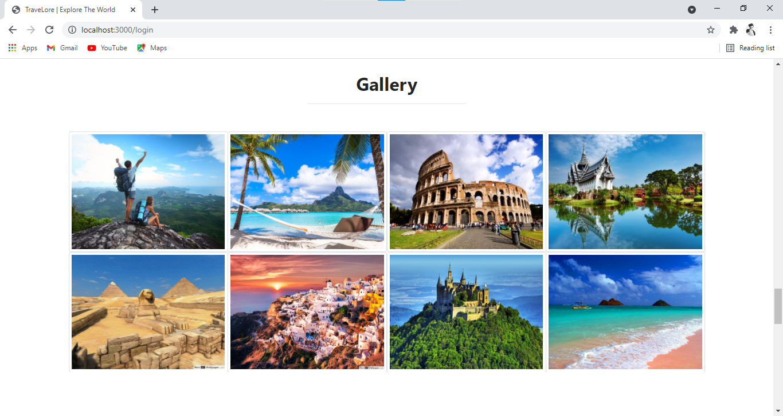

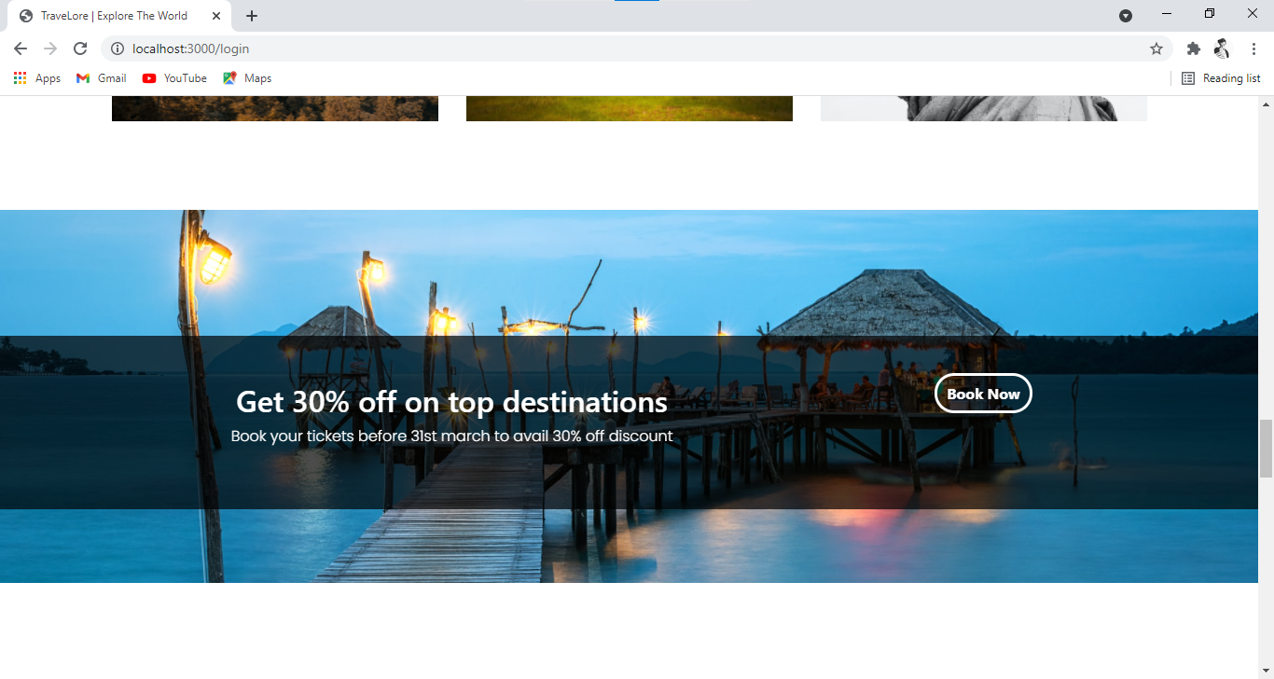

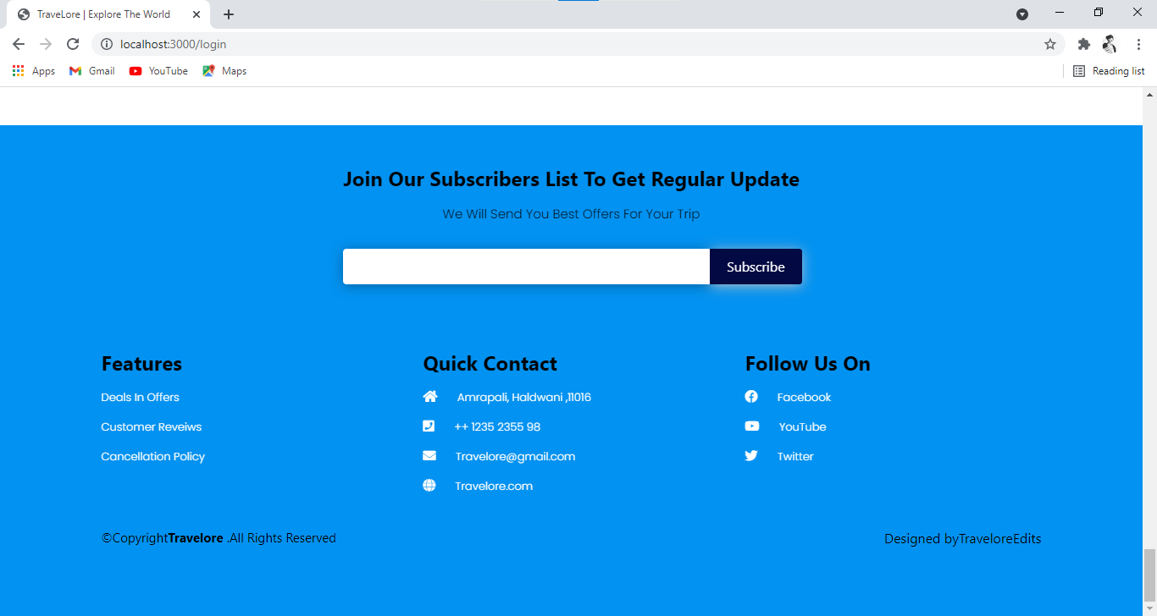

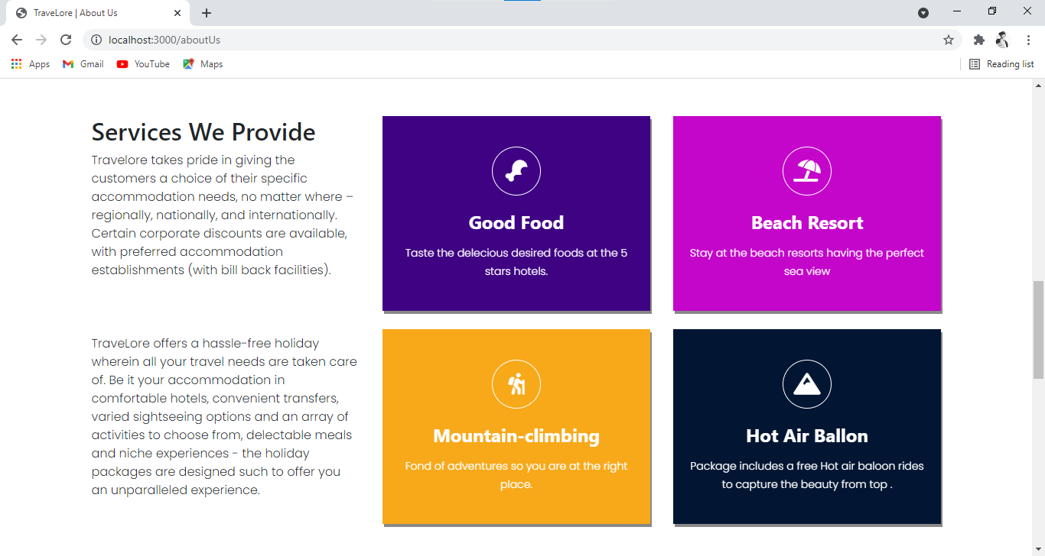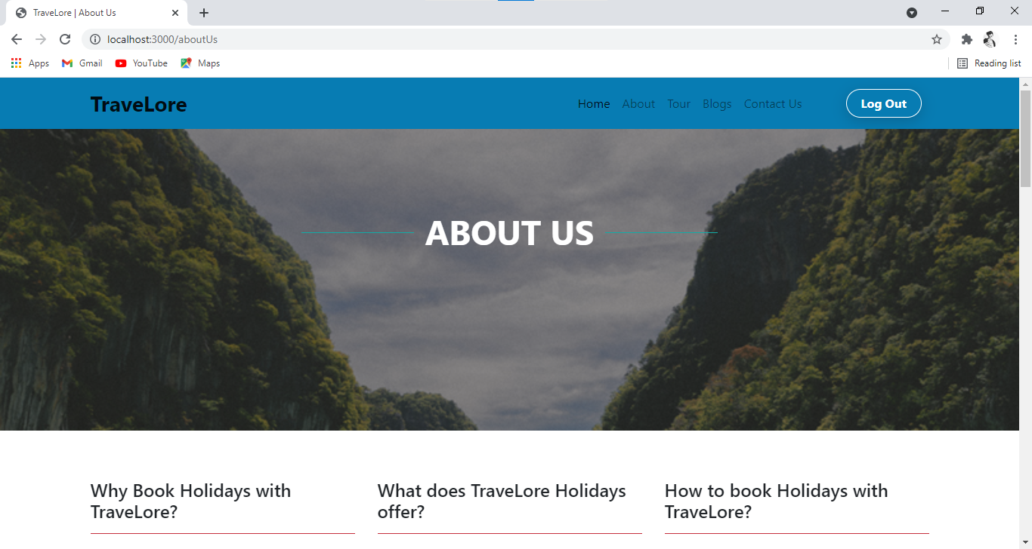

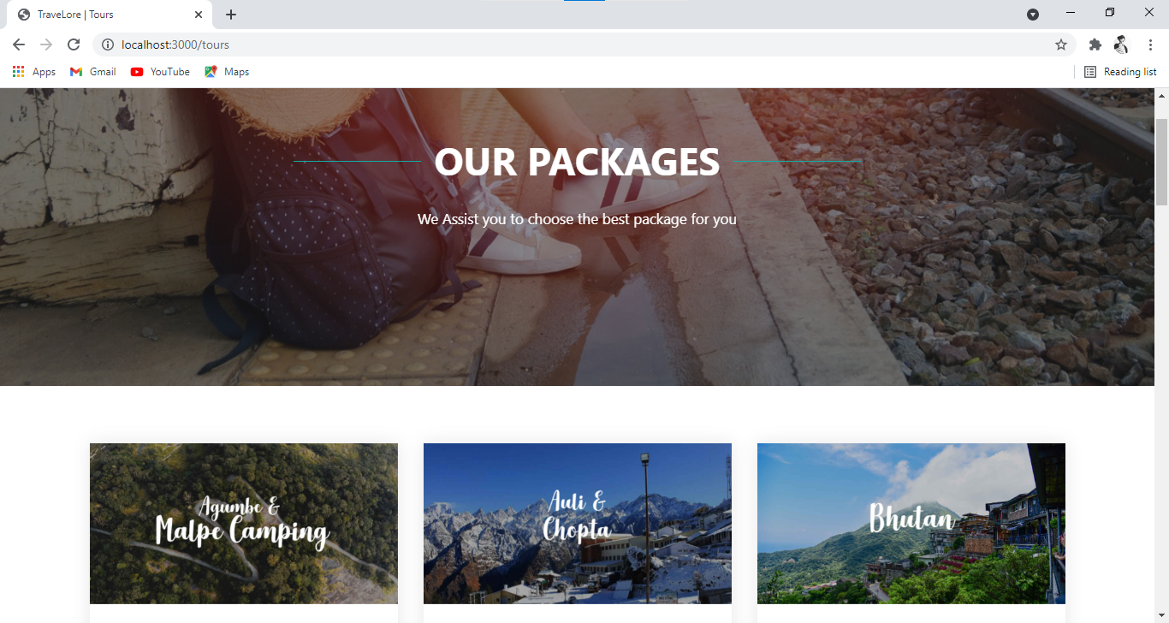

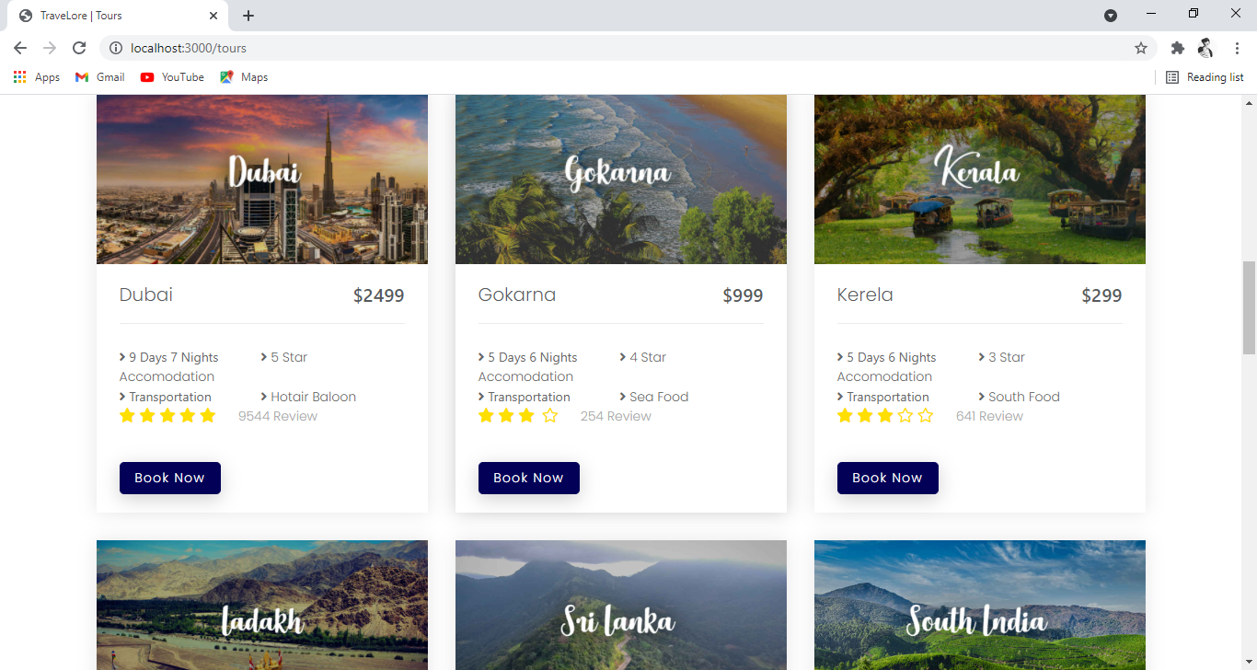

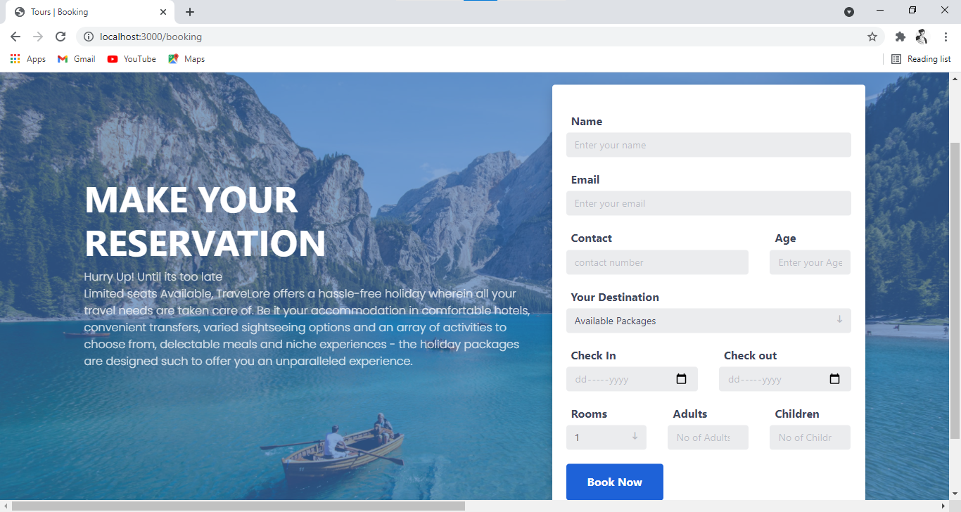

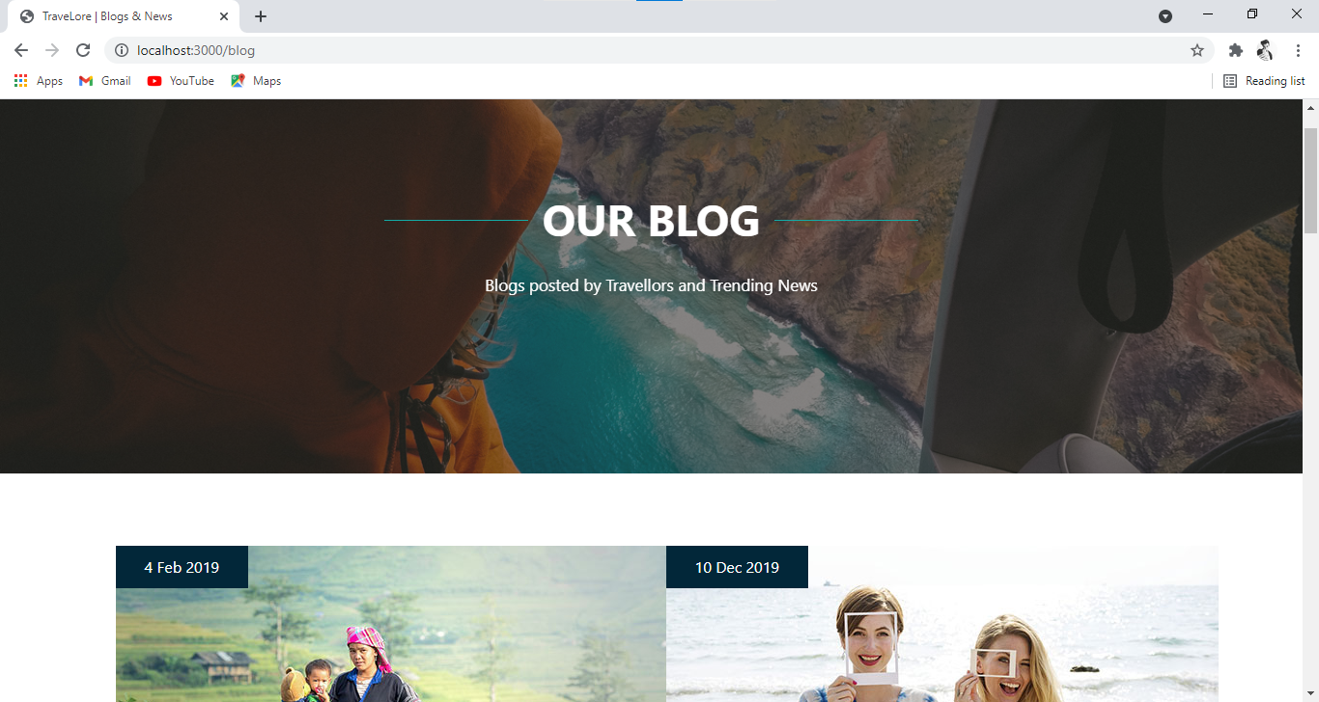

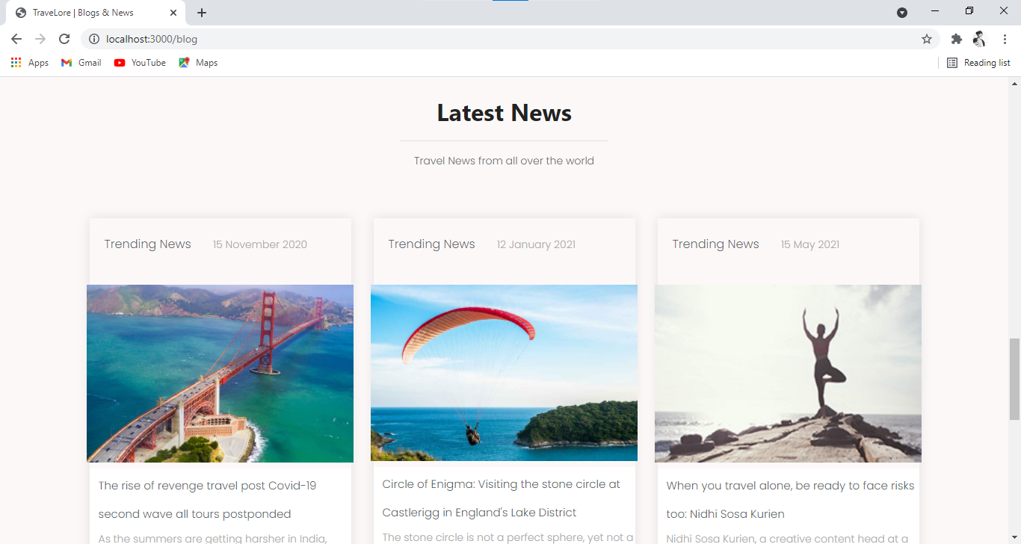

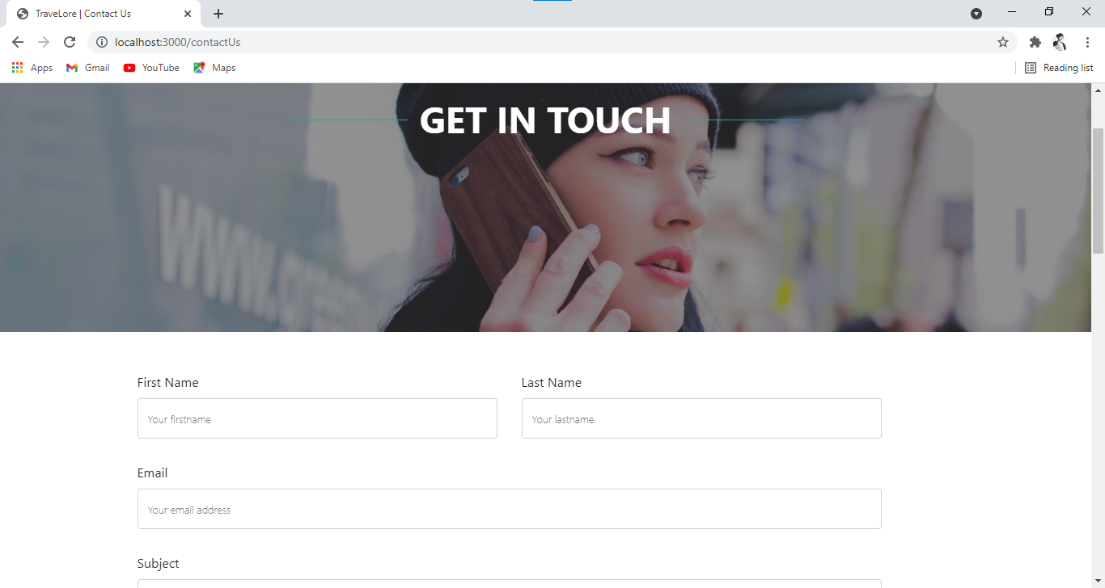

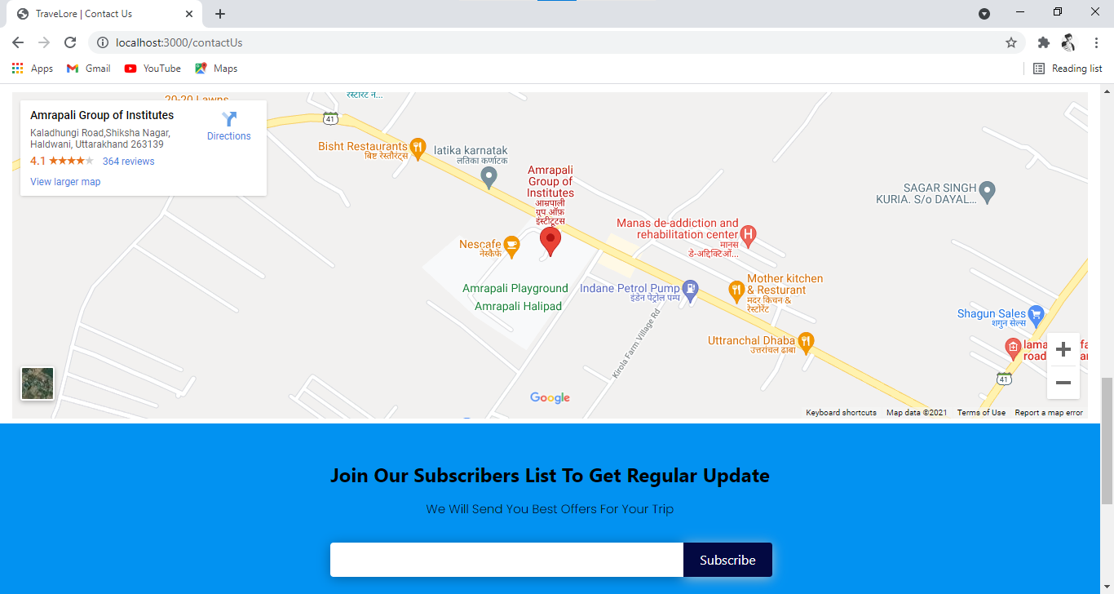

12 - ANNEXURE

# 12.1 - CONCLUSION

## WORK DONE:

The **“TRAVELORE”** was successfully designed and is tested for accuracy and quality.

During this project we have accomplished all the objectives and this project meets the needs of the organization .The developed will be used in searching, retrieving and generating information for the concerned requests.

## GOALS

* + - Reduced entry work.
    - Easy retrieval of information
    - Reduced errors due to human intervention
    - User friendly screens to enter the data
    - Portable and flexible for further enhancement
    - Web enabled.
    - Fast finding of information requested

# 

# 12.2 - Bibliography

## References

* Lee Purcell, Mary Jane Mara, “The ABCs of JavaScript”, Third Edition, 1996.
* Roger Pressman , “Software Engineering”, Fourth Edition, published by Tata Mc Graw Hill, Fifth Edition, 2001.
* Steven Holzener , “HTML Black Book” , by Coriolis Group Books , Second Edition, 2000

WEBSITES

* http://[www.theserverside.com](http://www.theserverside.com/)
* http://[www.java.sun.com](http://www.java.sun.com/)
* http://[www.javatpoint.com](http://www.javatpoint.com/)
* http://[www.W3cschool.com](http://www.W3cschool.com/)
* http://[www.stackoverflow.com](http://www.stackoverflow.com)
* [http://www.realitytoursandtravel.com](http://www.realitytoursandtravel.com/)
* [http://www.indiatoursonline.com](http://www.indiatoursonline.com/)